**JAYPEE UNIVERSITY OF ENGINEERING & TECHNOLOGY** Accredited with Grade-A+ by NAAC & Approved U/S 2(f) of the UGC Act,1956 A.B. Road, Raghogarh, District Guna (MP), India, Pin-473226 

Phone: 07544 267051, 267310-14, Fax: 07544 267011

Website: www.juet.ac.in

**Weekly Progress Report**

**Week No. __1__**

Name: Sapeksh Pareek Enrolment No. 211B274 . Period: 20/05/2024 to 26/05/2024 . Work done during Week (in detail)

In the first week of my internship, I began by learning Next.js and completed several small projects using provided references. I developed a LinkedIn scraper using Selenium to extract data on leads, company profiles, and industry details. Additionally, I worked on creating SaaS templates, including a landing page, login/signup page, and dashboard with a sidebar and profile dropdown settings. Concurrently, I delved deeper into React concepts, planned my learning path, and explored advanced topics. I also learned AI through tutorials and conducted experiments to build proof of concepts, enhancing my overall skills in web development and AI._____

Section/Department of Organization (Under which training is going on)

Work on the new SaaS template from MUI.com in the Material Design section. Fix all errors and bugs, link pages using React Router, and use Next.js as the backend.__________________________________________

Name of Supervisor: Ms. Anahita Zahl Tantra (HR, Yardstick)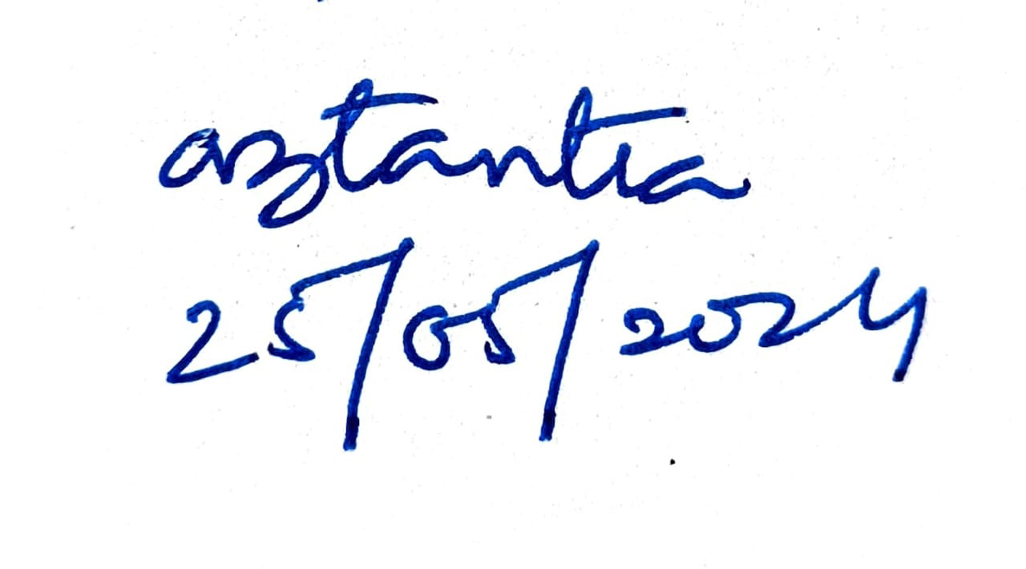

**Signature of Supervisor Signature of Student  
(with date) (with date)**